On a plastic product, you will usually find a triangle logo with a number (1 to 7) molded onto the bottom. This is a coding system that classifies different types of plastics, and whether a certain type of plastics is recyclable depends on associated facilities of the region. In Hong Kong, plastic # 1 and # 2 are more commonly recyclable.

Plastic #1 are made with polyethylene terephthalate (PET or PETE), commonly used in:
- Bottles for water and softdrinks;
- Box packaging for salad and delicate fruit such as blueberries;
- Peanut butter jars;
- Mouthwash bottles.
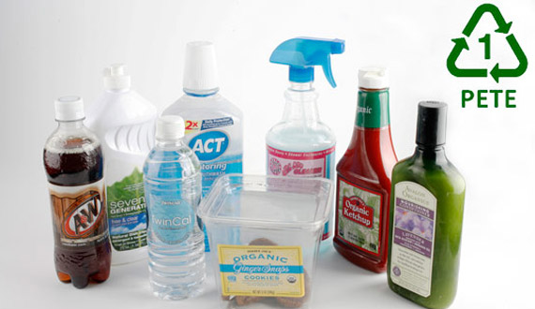

Plastic #2 are made with High-density polyethylene (HDPE), commonly used in:
- opaque bottles for milk and juice;
- containers for cleaning detergent and shampoo.
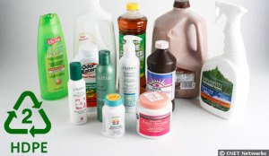

(source of photos: https://greenveg.com/know-your-plastic-recycling-number/)

